



HACKATHON on aws



TEAM MEMBER DETAILS

* A.DURGA YASASWINI * M.TRIVENI

* B.SRIYA * P.SAKULJI

* N.SHANKAR * B.ANURAGH

**STAGE-1:**

**Creating a VPC (Virtual Private Cloud):**

* In the VPC dashboard click on the “create VPC” Button to start the VPC creation wizard.
* Configure the VPC settings:
  + - Provide a name for your VPC.
    - Specify the IPv4 CIDR block for your VPC's IP address range ( 10.0.0.0/16).
    - Optionally, you can assign an IPv6 CIDR block to your VPC.
* Configure the VPC's subnets:
* Specify the IPv4 CIDR block for your first subnet (e.g., 10.0.0.0/24).
* Choose the availability zone where you want to create the subnet.
* Repeat this step to create additional subnets if needed.
* Configure the VPC's route table:
* Create a new route table or select an existing one.
* Associate the subnets created in the previous step with the route table
* Configure the VPC's internet gateway:
* Create a new internet gateway or select an existing one.
* Attach the internet gateway to your VPC.
* Configure the VPC's security groups:
* Create new security groups or select existing ones.
* Define the inbound and outbound rules for each security group to control network traffic.
* Review all the configuration details and settings for your VPC. If everything looks correct, click on the "Create VPC" button to create your VPC.

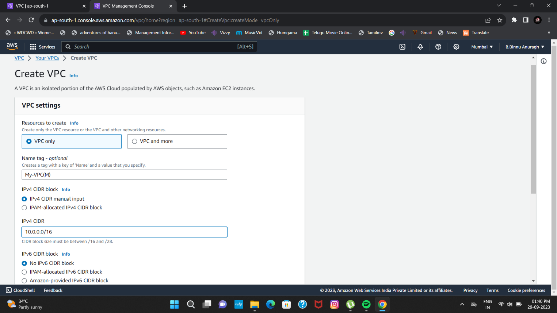

**INTERNET GATEWAYS (IGW):**

* **Go to the internet gateways option and create IGW.**
* **And then connect it to the vpc.**

**ROUTE TABLES (RT):**

* Go to the "Route Tables" section: Within the selected VPC, click on the "Route Tables" option in the left navigation menu. This will display the list of existing route tables in the selected VPC**.**
* Create a new route table: Click on the "Create Route Table" button to create a new route table within the selected VPC.
* Configure the route table settings:
* Provide a name for the route table to identify it.
* Select the VPC in which you want to create the route table.
* Choose the desired subnet associations for the route table. Subnets can be associated with multiple route tables, and each subnet must be associated with at least one route table.
* Configure the routes:
* Click on the "Edit routes" button to add or edit routes in the route table.
* 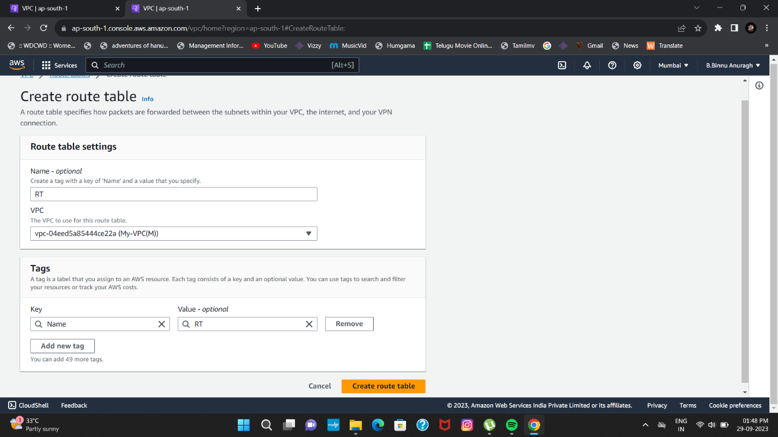
* Add the desired routes by specifying the destination IP range and the target (e.g., an internet gateway, a virtual private gateway, or a NAT gateway)
* Save the route table: Click on the "Save" button to save the configured route table.
* Associate subnets with the route table:
* In the "Associations" tab of the route table, click on the "Edit subnet associations" button.
* Select the subnets you want to associate with the route table and click on the "Save" button.
* Review the route table: Verify the route table settings, associations, and routes in the AWS Management Console.
* Create a new route table: Click on the "Create Route Table" button to create a new route table within the selected VPC.

**PUBLIC SUBNET**

* Click on the "Create Subnet" button to create a new subnet.
* Configure the subnet settings:
* Select the VPC in which you want to create the subnet.
* Provide a name and a suitable CIDR block for the subnet. Ensure that the CIDR block falls within the IP address range of the VPC and doesn't overlap with other subnets
* Select the desired availability zone for the subnet. It's recommended to create subnets in multiple availability zones for high availability and fault tolerance.
* Configure the subnet's route table:
* Choose an existing route table or create a new one for the subnet. To make the subnet public, associate it with a route table that has a route to an internet gateway.
* Verify the details of the subnet, including the VPC, CIDR block, availability zone, route table, and NACL settings
* Once you have reviewed and confirmed the configuration, click on the "Create" button to create the public subnet.
* 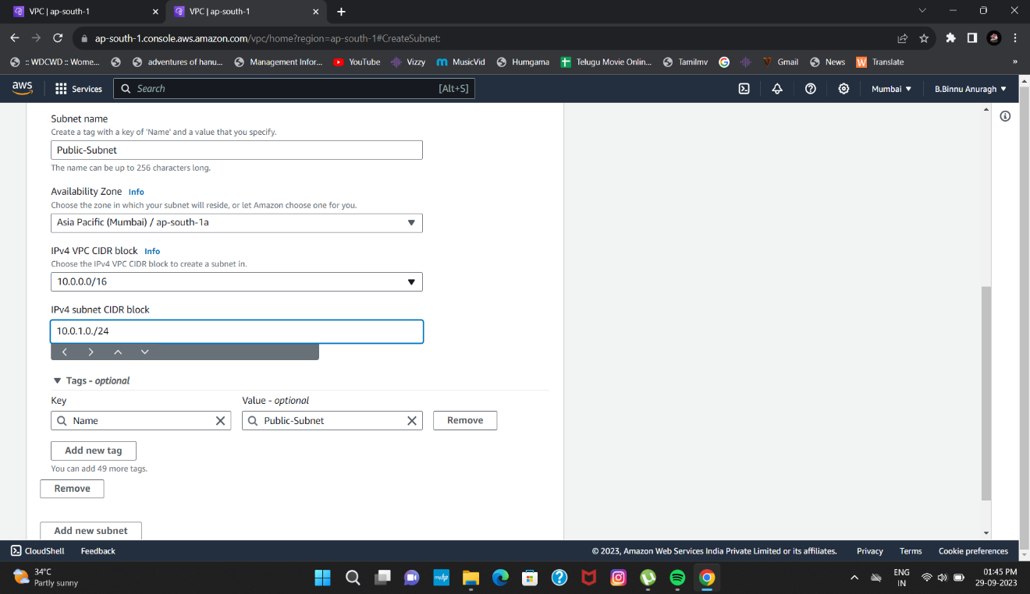If you require multiple public subnets across different availability zones, repeat the above steps to create them.

**NAT GATEWAYS**

* Click on the "Create NAT Gateway" button to create a new NAT gateway.
* Configure the NAT gateway settings:
* Select the subnet in which you want to create the NAT gateway. The subnet must be a public subnet, meaning it should have a route to an internet gateway.

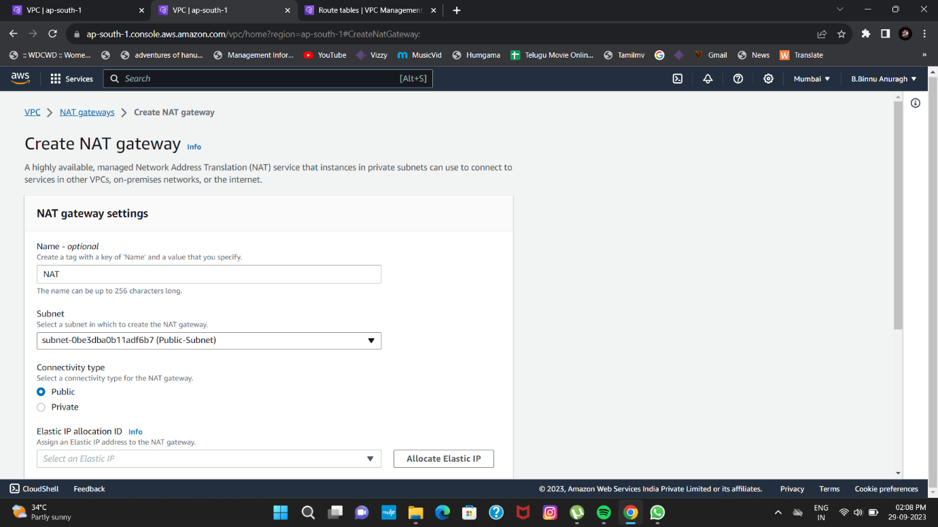

* Choose an existing Elastic IP address or allocate a new one to associate with the NAT gateway. The Elastic IP address serves as a public IP address for the NAT gateway.
* Verify the configuration details for the NAT gateway, including the selected subnet and Elastic IP address
* Click on the "Create NAT Gateway" button to create the NAT gateway. The creation process may take a few moments.
* Update route tables: After the NAT gateway is created, you need to update the route tables to direct the outbound traffic from private subnets to the NAT gateway.
* Go to the "Route Tables" section in the VPC Dashboard.
* Select the route table associated with the private subnets that need access to the internet via the NAT gateway.
* Add a new route with a destination of "0.0.0.0/0" (or the desired IP range) and set the target as the newly created NAT gateway.
* Test the connectivity by launching an instance in a private subnet and ensuring it can access the internet through the NAT gateway.

**PRIVATE SUBNET**

* Click on the "Create Subnet" button to create a new subnet.
* Configure the subnet settings:
* Select the VPC in which you want to create the subnet.
* Provide a name and a suitable CIDR block for the subnet. Ensure that the CIDR block falls within the IP address range of the VPC and doesn't overlap with other subnets
* Select the desired availability zone for the subnet. It's recommended to create subnets in multiple availability zones for high availability and fault tolerance.
* Configure the subnet's route table:

Choose an existing route table or create a new one for the subnet. To make the subnet public, associate it with a route table that has a route to an internet gateway.

